Web Development Lesson Plan

|  |  |  |
| --- | --- | --- |
| Session: 1 | Topic: Unix commands and file structures | Day: 5 |

|  |
| --- |
| Lesson Objective:  This exercise will:   * Improve students’ ability to work with basic Linux commands and understand file structures.   The purpose of this lesson is also that   * Students can navigate file structures through a terminal. |
| Materials Needed:   * Visual Studio Code |
| Agenda:   1. What is Unix (10 minutes) 2. Why we use Unix (10 minutes) 3. Navigating file structures through the terminal (20 minutes) |
| Procedure:  Student can do this fully independently by reading the instructions, or someone can read the instructions to make sure the task is understood before doing the activity. The reflection part can be done with guided instructions, or in pairs with other students if available to compare notes. |
| Assessment/Check for learning:   * Students can identify concrete things that they missed in their observation (note that this is not a bad thing, the purpose of this lesson is to realize that intentionally looking for information comes with the ‘penalty’ of reduced attention to other things. |

What if:

* Student has already shown proficiency in that skill?
  + Pick a movie or episode in which a lot of things are happening, so that there are more things for the student to keep track of.
* Student is having a hard day and needs special accommodations?
  + Pick a movie or episode in which only a few things are happening, so that there are less things for the student to keep track of.
  + Instead of writing, the student can also take spoken notes with an audio recorder. This will be a bit trickier in the second part but audio in the movie can be supported with subtitles.

NOTES:

* Duration is approximately 50 minutes; can be adjusted by shortening the duration of the film clip. Less than 10 minutes is not recommended unless really necessary.

**Instructions**

**What is Unix (10 minutes)**

Step 1:

Unix is an operating system, similar to Windows or Mac OS. Linux contains many features that are useful for developers. We will not be using the Unix operating system, instead we will only use basic Unix commands within Visual Studio Code.

Step 2:

Read the following article to learn about Unix:

<https://users.cs.duke.edu/~alvy/courses/unixtut/unixintro.html>

**Why we use Unix (20 minutes)**

Step 1:

Unix comes in handy when programming. It offers quick fast file management tools and can even be used to test and debug code. For this course we will be Unix commands to navigate files and folders within the Visual Studio Code terminal. You do not need to become a Unix expert. We will only cover basic commands that are helpful.

Step 2:

Watch this video to understand why Unix is useful:

["Everything is a file" in UNIX](https://www.youtube.com/watch?v=dDwXnB6XeiA)

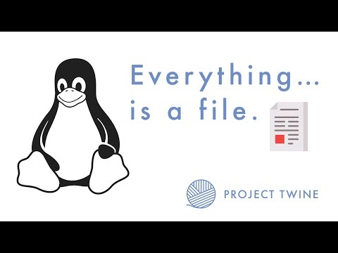

**Navigating file structure through the terminal (20 minutes)**

Step 1:

The commands that we will use the most are:

* **cd**: Changes directory (folder)
* **ls**: lists contents of directory (folder)
* **mkdir**: Makes a new directory (folder)
* **clear:** Clears the contents on the terminal window
* **pwd:** Displays the current file path

These five commands are all we need to know to navigate through file structures.

Step 2:

Open Visual Studio Code.

Step 3: Once Visual Studio Code is open, create a new terminal navigating to **Terminal > New Terminal** in the menu bar of Visual Studio Code.  
The screenshot below shows how to open a terminal:

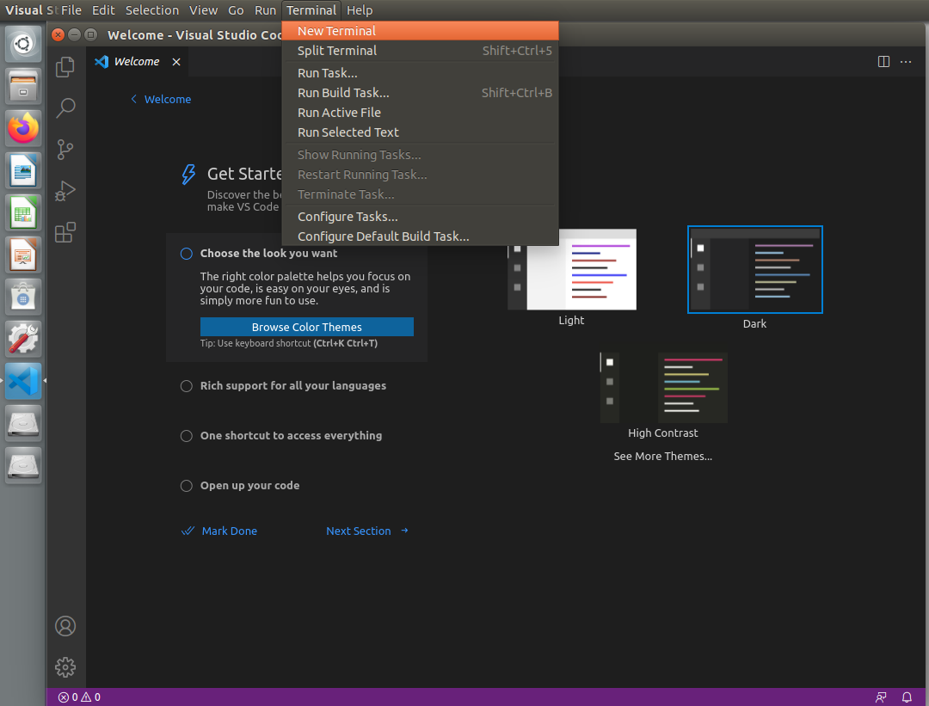

Step 4:

You should now see a terminal window at the bottom of Visual Studio Code.

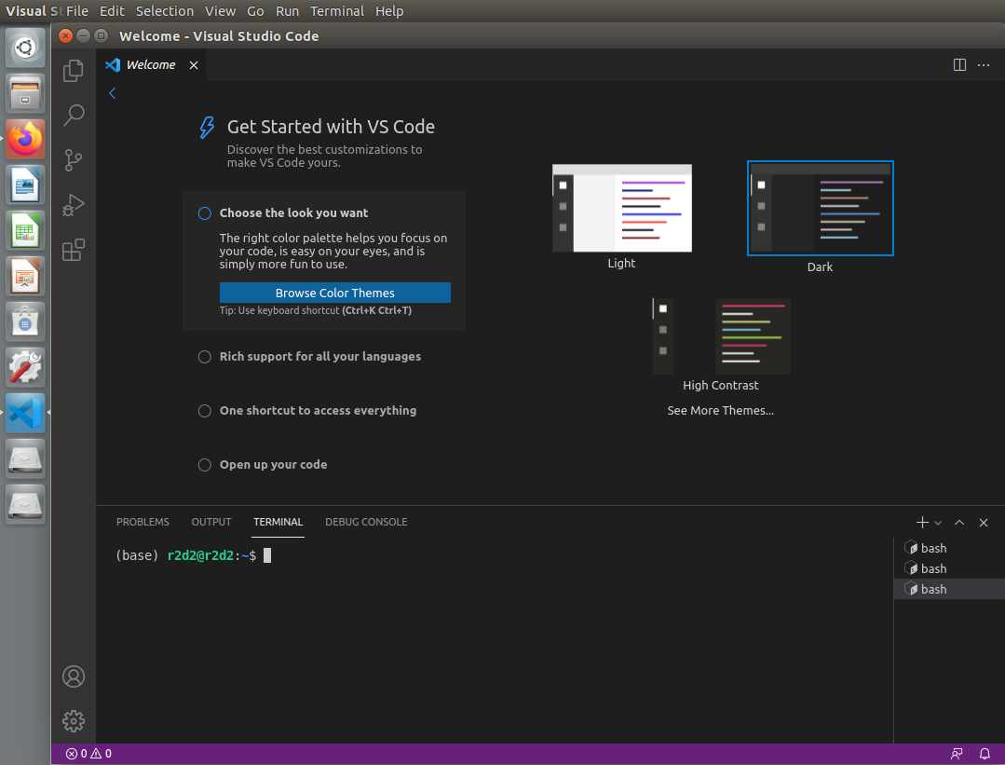

Step 5:

Type **ls** to view a list of files that are within the current directory. In the screenshot below you can see the files that are within the current directory, this will be different on your computer.

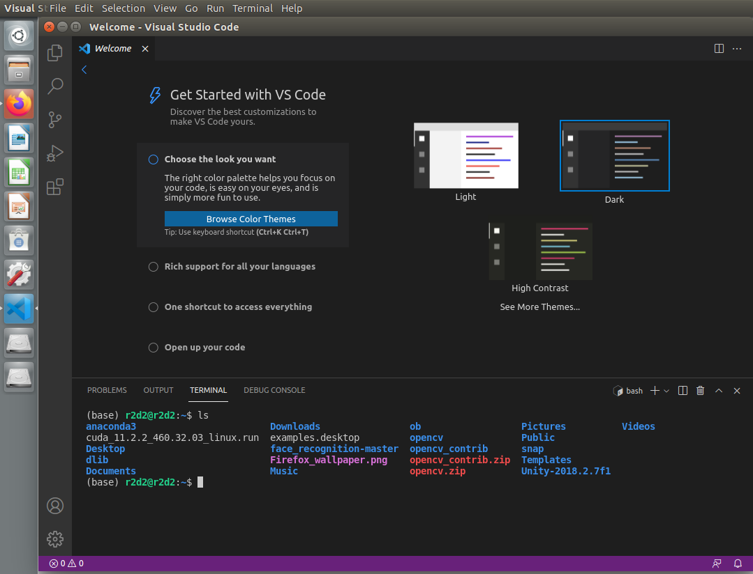

Step 6:

Let’s make a new folder. This folder will be called “lesson5Folder”. To make the folder type **mkdir lesson5Folder** into the terminal and press enter.

The above line specifies the command we want to use, which in this case is “mkdir” and then we specify the name we want to give the folder, which in this case is "lesson5Folder”.  
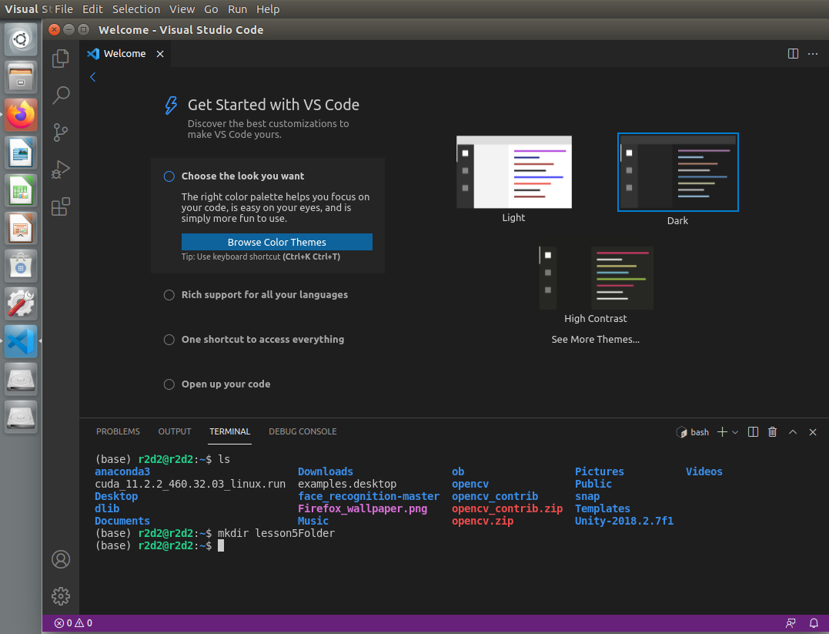

Anytime you want to make a new folder just use the “mkdir” command plus the name you want to give the folder.

Step 7:

Let’s make sure the folder was made. To do this we will list all the items in the current directory. In the terminal type **ls** and press enter. You should now see the folder in the list of items.

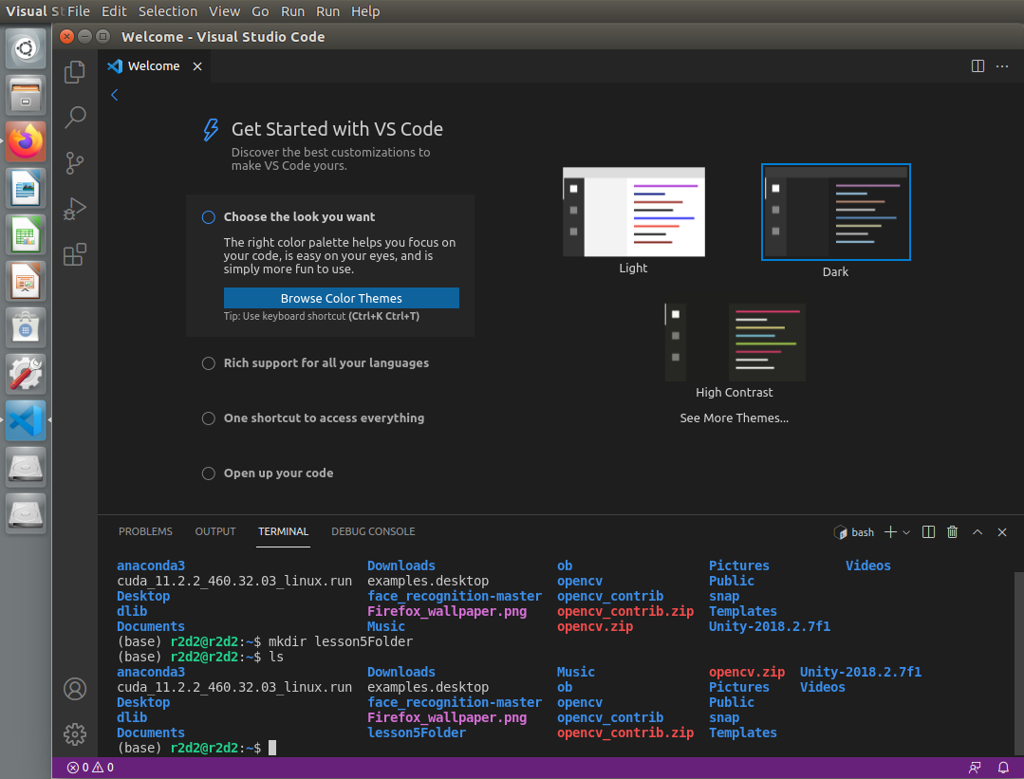

Step 8:

We will now change directory. We will change into lesson5Folder. Note: changing directory means that we are simply just opening a folder to view its content. To change into lesson5Folder type the following command into the terminal **cd lesson5Folder**

The command above uses the “cd” (change directory) command to open the folder named “lesson5Folder”

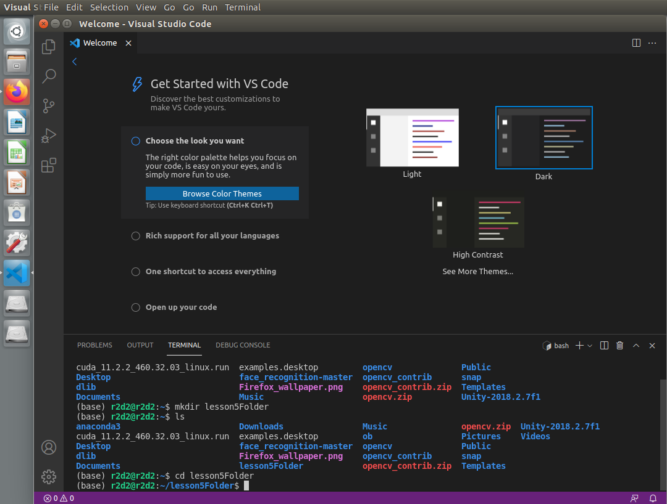

Step 9:

To make sure that we are in lesson5Folder type **pwd** into the command. This will display the current file path.

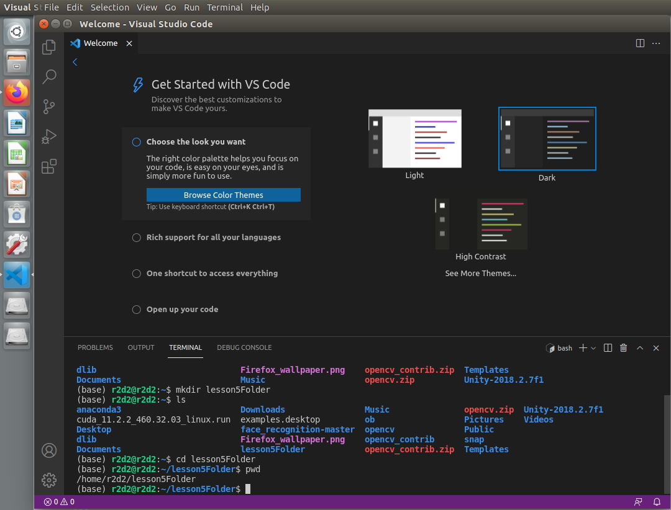

Step 10:

To navigate back to the previous folder type **cd ..**

This command will take us to the folder we were just in. Type **ls** to view the contents of the directory.

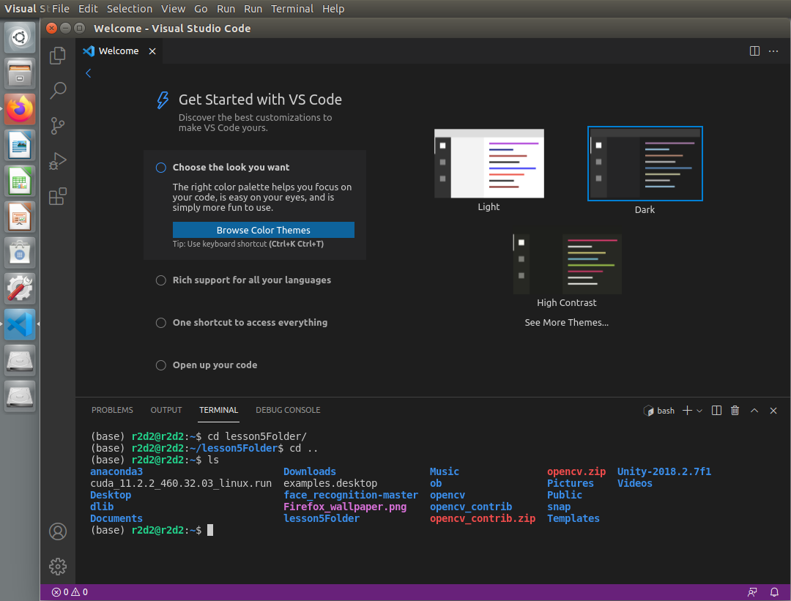

Step 11:

Finally, to clear the contents of the terminal window you can type **clear**

This makes it easy to remove distracting elements without opening a new terminal.

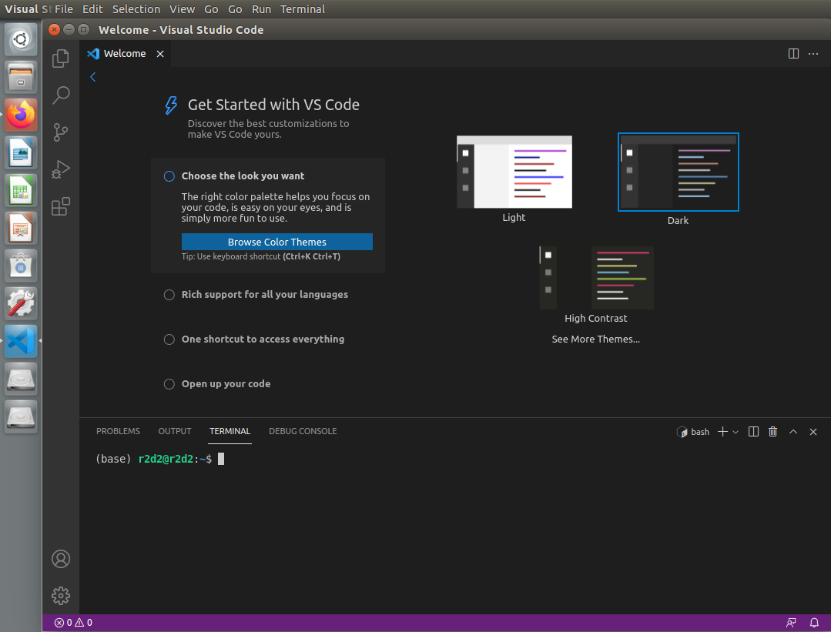

In the next lesson you will receive an introduction to the Python programming language.